Válvula Check Piloteada Doble BSP

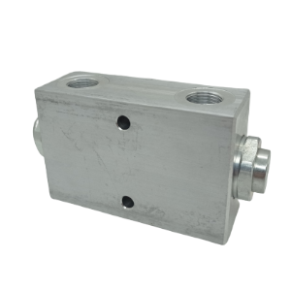
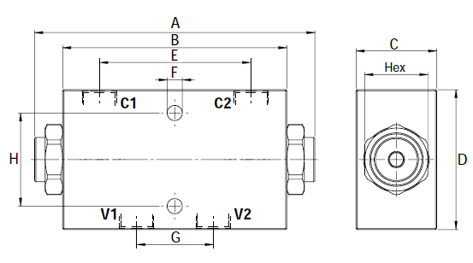

CODIGO | DESCRIPCION | C1-C2-V1-V2 | MAX PRESSURE BAR | A | B | C | D | E | F | G | H | HEX | RATED FLOW LPM
OFCVCPDLVDL15 | Valv.Check Pilot.Doble 3/8"BSP 20l/min | 3/8" BSP | 260 | 113 | 90 | 25 | 50 | 62 | 6,5 | 32 | 40 | 22 | 20
OFCVCPDLVDL02 | Valv.Check Pilot.Doble 3/8"BSP 35l/min | 3/8" BSP | 260 | 113 | 96 | 35 | 60 | 62 | 6,5 | 32 | 40 | 22 | 35
OFCVCPDLVDL25 | Valv.Check Pilot.Doble 1/2"BSP 35l/min | 1/2" BSP | 260 | 113 | 96 | 35 | 60 | 62 | 6,5 | 32 | 40 | 27 | 35
OFCVCPDLVDL03 | Valv.Check Pilot.Doble 1/2"BSP 50l/min | 1/2" BSP | 260 | 140 | 110 | 35 | 70 | 69 | 8,5 | 34 | 40 | 30 | 60
OFCVCPDLVDL04 | Valv.Check Pilot.Doble 3/4"BSP 100l/min | 3/4" BSP | 260 | 200 | 165 | 50 | 90 | 105 | 8,5 | 50 | 60 | 41 | 100

